Claire Lowe-Year 12
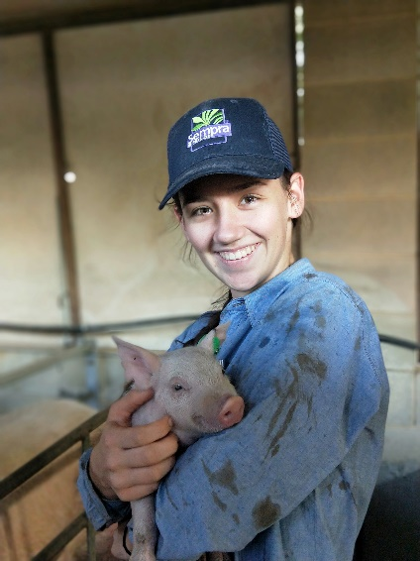
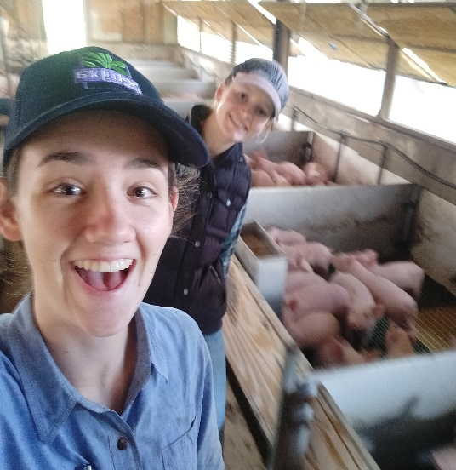
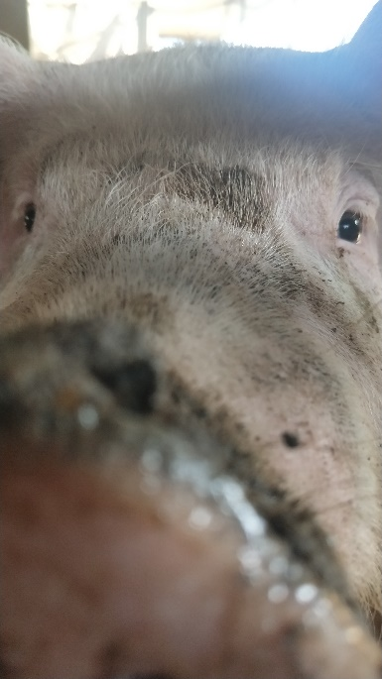
Agricultural Science
Extended Agricultural Investigation (EAI)

Farm Systems Analysis
of an Intensive Piggery
Table of Contents:
Industry Overview________________________________1
PART A: Farm Systems Analysis_____________________1
Introduction_____________________________________3
Inputs__________________________________________4
Sub-Systems____________________________________5
Animal Production Sub System______________________5
Feeding Sub System______________________________8
Housing Sub System_____________________________10
Management Sub System_________________________15
Marketing Sub System___________________________16
Outputs_______________________________________16
Impacts on the System___________________________16
Systems Model_________________________________18
PART B: Problem Solving Task_____________________19
Conclusion_____________________________________25
Acknowledgements______________________________25
Appendix______________________________________26
References_____________________________________29
Power Point____________________________________32

Industry Overview:
Although not Australia’s favourite meat, pork is becoming increasingly popular. There are three different methods of pig production in Australia: indoor, outdoor bred and free range-with some farmers combining more than one method. Queensland holds approximately 22.4% of the national pig herd. This consists of around 61,624 sows across 280 herds. In the financial year ending in 2017, the value of domestic pork production was over $1.27 billion dollars. In Queensland in particular, the approximate value of pig farming was $269 million in 2015. This was as a result of a total slaughter increase of 5.2%, or 397,000 tonnes of meat (APL, 2017). Even though the industry is excelling, it hasn’t been without hardship. In the last few years, the Australian pig industry has faced many events that combined to put pressure on people from all aspects of the production chain. This included new animal husbandry policy, a drop in market price, increase in grain cost as well as competition from imports. In particular, market price has had one of the biggest impacts. In 2016, prices were at a high $3.75 per kilo. However, from the end of that year onwards, prices only dropped. By 2017, price per kilo dropped to under $3, with the current price at time of writing sitting around $2.70/kilogram (Financial Review, 2018). This drop in price can be associated directly with the increase of imports. In 2015, only 38,000 tonnes of meat was exported in comparison to the 172,000 tonnes imported (Daf.qld.gov.au, 2018). Although most Australian pork is consumed within the country, the product is exported to nearly 40 countries around the world, with the main ones being Singapore, Hong Kong and Germany.
These factors combined have made the last few years hard for the industry, however the consumer has managed to stay supportive. Australians consume 10.5kg of fresh pork and 15.5kg of processed pork, to make a combined total of 26kg of pork consumed per person per year.

Part A: Description of the Farm System

Introduction:
Morganbury meats Pty Ltd is part of a large-scale business: Greenwood Farming Pty Ltd. Owned by George and Terry Greenwood, the manager of this particular property is their son, Chris Greenwood. Chris is also the general manager of the vertically integrated business, as well as other businesses. The one hundred and twelve hectare property is located at 77 Morganbury Road, Walkamin, Queensland, roughly ten minutes from Atherton. The land is made up of rolling plains, with some gullies and a creek bed present at the creek that runs through the property: Maud Creek. Although most vegetation was originally cleared, some plants species such as bloodwood and ironbark are still present. Even though irrigation is not needed for pasture, the farm has a 300 megalitre per year contract through the Mareeba-Dimbulah Irrigation scheme. Bounded by fence, woodlands and roads, this property contains two separate enterprises. One being a cattle feed-lot and the other an intensive piggery, with the intensive piggery being of main interest and the enterprise being investigated. Managed by Helen Bensilum since 2007, the piggery is a farrow to finish production system, and is capable of housing 290 sows.
Greenwood Farming has a vision and a mission statement. The combination of these two is equivalent to the purpose of the system. The statements are as follows;

Vision:
To cost effectively produce and market world class product from healthy and efficient livestock while at all times being ecologically sustainable.
Mission Statement:
We are committed to achieving our vision through attention to detail and utilization of best management practices in all aspects of our operation including environment, occupational health and safety and quality management systems so as to ensure the best possible results.
Overall, Morganbury meats have a desire to produce a quality product that is economically viable as well as environmentally friendly. In addition, the company also has production objectives specific to the facilities capabilities. Although not always achieved, the facility has a 61 kilogram dressed weight goal, as well as an 85kg liveweight target. Furthermore, the number of sows is ideal at 290.

Inputs:
Being a commercial intensive business, there are a range of inputs that are necessary in ensuring constant production of pork. One of the most important inputs is food. This is sourced from the local feed mill, Advanced Rural, which is located roughly twenty minutes drive away from the property. Another key input is the animals themselves. Although Morganbury Meats does have its own breeding program, animals are often bought and brought in to benefit the business and improve the herd genetics. If not picked from litters, breeding females are bought from Eastern Genetic Resources in Bell, Queensland. Boar semen used for Artificial Insemination (AI) is also purchased from here. However, replacement breeding boars are selected from Premier Pig Genetics in Kingaroy, Queensland. These companies are crucial in ensuring the genetics and production of Morganbury Meats is optimal. The last major input is the employees. Within the business, there are three main employees. Helen (the manager) oversees the work of the two other employees, Terry and Emma, as well as writing reports and working with the genetics of the heard. Terry is in charge of the practical side of genetics as well as general maintenance. The last employee, Emma, works as a nursery hand-feeding, cleaning and keeping the herd generally healthy. Without these employees and their specific roles, it is likely that the farm would not run as smoothly.
As briefly mentioned earlier, the enterprise is supplied with 300 ML of water a year through the Tinaroo Dam. This allows a more than sufficient amount of water for the pigs, as well as enough for other uses such as flushing and cleaning. Other inputs include the local veterinarian, chemicals as well as a pig nutrition specialist. The local vet is responsible for identifying and providing solutions for herd health. The recently-employed pig nutrition specialist has a main goal of ensuring what the pigs are eating is right, so all round benefits can be seen. This includes overall fertility and grower rates.
There are also a large range of other inputs that are paramount for the businesses’ smooth running. Originally, the materials used to build the facility such as bricks, cement, iron, farrowing crates and stalls were bought. Other smaller inputs that are constant in everyday production include silos, wheelbarrows, feeders, taps, shovels, buckets, carts, injectors, vaccines, pumps, lights, hoses, chemicals and pressure cleaners. Most of these products are sourced from local agriculture supply shops. Without these smaller items, the enterprise would not function properly.

Sub-systems:

Animal Production Sub System (APSS)
There are many farming enterprises that could have been chosen when the land was first bought by the owners. However, pigs were chosen for a few reasons. As the land size is only fairly small, it was decided that some form of intensive production would be chosen. The owners believed that there were already enough intensive chicken farms in the area, and that pigs would provide them with a sustainable income. As well as this, pigs are highly efficient protein producers, with 75% of the carcass used for meat, compared to the 55% of cattle. Another factor that influenced the choice was the fact that pigs can have multiple progeny per sow, meaning more animals could be produced and therefore more meat sold.
The purpose of this system is to produce pork that is accepted by the market. With that in mind, Large White x Landrace breed was chosen. The Australian market desires white meat with white skin, so this contributed to the choice of LW x Landrace, as both breeds have no black hair (NSW DPI, 2005). Both breeds have different traits that are desirable, thus why the two were crossed. The Large White is known for its efficient mothering skills and bulky shoulders. On the other hand, the Landrace boasts extra ribs and a large eye muscle area. This combination of desirable traits results in hybrid vigour; a situation where the animal produced is superior when compared to a non-hybrid.
The piggery is a farrow to finish system, meaning the piglets are born there, and the end product is also sold there. On top of this, Morganbury Meats also utilizes an all-in, all-out system. This means that a group of animals will stay together for most of their lives, from piglets to porkers. For example, sows will be mated to farrow around the same time so their litters can move on together as a group. Their litters will move into weaners, into growers and into porkers all at the same time. This reduces cross-breeding, risks of disease and also allows the manager to have better control of the enterprise. This said, the business aims to have around 5,800 finished beasts a year, with 110 porkers slaughtered a week being ideal. The table below shows general production time frames.
Figure 1: Production Time Frames
Stage of Life: | Age: | Husbandry Practices:
Selected Gilts: | 23 weeks onwards | - Gilts ‘selected’ first in the farrowing crate, then again at 23 weeks  - Contact with a boar from approximately 25 weeks, pregnancy tested days post mating  - If positive test; stay in group housing until day 112 of pregnancy, then moved to farrow shed.  - In farrow shed, induced day 113.  - Success in farrowing: 25 days of lactation, then serviced 5.5 days after being weaned  - If negative test; rebred up to 2 times, then culled if not pregnant
Selected Boars: | 28 weeks onwards | Days 7-14: Initially ‘selected’ in farrow crate  16-19 Weeks: Re-assessed for final selection  28 weeks: Moved to mating shed  30 weeks: Begin servicing  38 weeks: Successfully mating
Dry Sows: | Post weaning | - Weaned on a Wednesday  - Re-mated on a Sunday. (Boars of similar size to the sow are joined)  - For AI, sows receive 2 bottles on Monday at approximately 11am, and then the again at the same time the next day  - Stay in crates until 28 days post-service-then pregnancy tested  - Positive test; group housing until 5 days pre farrow  - Negative test; re-mated up to two times, and then culled if not pregnant
Lactating Sows: | Any time after being successfully mated | - Crate clean and disinfected (before the arrival of the sow)  - Sow washed before moving  - Day 112 (of pregnancy): moved to farrowing shed  - Day 113: Induced with 2mL of Lutylase & 1mL of Syntocin  - Deceased animals removed day one of lactation
Birth (suckers): | Zero days to day 25 | Day 3: Teeth clipped, tail docked and ears notched (identification)  Day 25 (approximately): All piglets weaned  - Clostat sprayed daily on mother’s teats
Weaners: | Day 25 to | First seven days: Heat lamps  - Grouped according to size and gender. For example, large females, medium females and small females.  - Some electrolytes added to water  - Shutters are adjusted as needed
Growers: | Weeks 8-10 | - Grouped in pens of 12  - Each week, move to a bigger pen
Growers-Finishers: | Weeks 10 + | - Move to ‘top shed’ facility  - Reporcin (hormone) is administered to finishers 3 times a week for the last 3 weeks (until sale)
Slaughter | Anywhere past the finisher stage | - Animals selected for slaughter depending on weight and size
**NOTE: - For housing: See ‘Housing Sub System’
- For Vaccinations, see Figure 2.
- For Feeding Rations, see Figure 3.

To try and achieve this goal, there are a range of husbandry practices that are undertaken on the property. Animals are fed daily, have access to water ad lib and their housing environments are cleaned often. Workers monitor all animals and check their health, as well as open and close the sheds for temperature regulation. Other practices such as teeth and tail are also crucial for animal welfare. On day 3 of life, teeth are cut by workers using pliers or forceps. This is done to ensure the safety of other pigs, as well as reduce damage to sows teats (and therefore milk distribution). Furthermore, the tails of piglets are also cut to prevent animals from biting each other. The part of the tail left contains nerves, which will alert the pigs if another is biting them (Australian Pork, 2018).
On top of this, vaccinations (see Figure 2), mating, pregnancy testing and weaning are also jobs that need to be completed often. Wet sows are also sprayed daily with Clostat, a probiotic that is used to reduce the presence of clostridia and therefore scours. As well as this, Staldren, a pink calcium carbonate based powder that is used to disinfect is also occasionally distributed into creeps. Workers may also administer antibiotics to particular animals when they deem it necessary. A range of important statistics such as pregnancy rates, birth rates and farrowing success are also recorded, along with genetic data.
Figure 2: Vaccinations Given to Particular Age Groups
Group: | Vaccination Given: | Technique: | Administered:
Selected Gilts | 4mLs EcoVacLE | Intramuscular | Approx. 23 weeks.  Repeated 28 days later.  Repeated 3 weeks prior to Farrow.
 | 2mLs Parvac | Intramuscular | Approx. 23 weeks.  Repeated 28 days later.  Repeated at weaning.
 | 2mLs Resipure Two | Intramuscular | Approx. 23 weeks.  Repeated 14 days later.
 | 1mL/33kg Bomectin | Subcutaneous | Approx. 23 weeks
 | 1mL Circoflex | Unknown | At weaning.
- Sore or lame gilts treated with Flunix & Norocillin as needed.
- Coughing treated with Engemycin as required.
Selected Boars: | 4mLs EcoVacLE | Intramuscular | Approx. 28 weeks.  Repeated 28 days later.
 | 2mLs Parvac | Intramuscular | Approx. 28 weeks.  Repeated 28 days later.
 | 2mLs Resipure Two | Intramuscular | Approx. 28 weeks.  Repeated 14 days later.
 | 1mL/33kg Bomectin | Subcutaneous | Approx. 28 weeks.
 | 1mL Circoflex | Unknown | Approx. 28 weeks.  Repeated 1 month later.
- Sore or lame boars treated with Flunix & Norocillin as needed.
- Coughing treated with Engemycin as required.
- Some treated with Big L wormer (if needed).
Dry Sows: | 4mLs EcoVacLE | Intramuscular | 3 weeks prior to Farrow.
 | 1mL Circoflex | Unknown | At weaning.
- Stockholm tar used for shoulder sores or Norocillin Sa
- Lameness/meningitis treated with Norocillin SA or Flunix
- Coughing/pneumonia treated with Engemycon
Wet Sows: | See ‘Dry sows’
- Ultrapen/Flunix/Syntocin used for MMA (Mastitis, Metritis, Agalactia) problems
Suckers: | 1mL Feron+B12 | Intramuscular | Day 3
 | 1mL Baycox Oral | Oral | Day 3
 | 1mL Clostat | Oral | Day 3
 | 1mL Circoflex | Intramuscular | Days 7-14
 | 2mL Respisure Two | Intramuscular | Days 7-14.  Repeat at weaning.
- 0.5mL Excernal RTU/oral Tribissen used to treat scours
- Septic Arthritis treated with Betamox/Flunix.
Weaners: | Lincomix 2.5kg/tonne feed | In feed | First 6-8 weeks.  Removed unless needed
- Meningitis treated with Lincospectin/Dexapent.
- Septic Arthritis treated with Betamox/Flunix.
- Pneaumonia treated with Engemycin.
- Scours treated with Lincospectin/Excernal RTU
Growers: | See ‘weaners’.
While all the above animal husbandry practices are important, there are some restraints within the enterprise that contribute in preventing the manager from achieving what they want to. The first is the pressure felt from the market demand as a result of vertical integration. As a result of being vertically integrated, the business must slaughter a certain number of porkers and baconers each week. This is sometimes challenging for the manager, as there may not be enough animals to send that are suitable for slaughter. This often results in pigs sent that are not yet ready for market, or not enough being sent-which results in an overall loss for the business. Another problem that restricts the managers goals is the humidity in the sheds. This humidity stresses the pigs, causing weight loss, a lower FCR rate as well as reduced fertility rates.

Feeding Sub-System (FSS)
The purpose of the FFS is to ensure pigs are maintaining production goals. Being an intensive system, workers are responsible for ensuring animals are well fed. Unlike a free range system where pigs have constant access to pasture, pigs in intensive units can only access what they are given. As in all livestock farming, animals at different stages of life or purpose are fed differently to ensure maximum output is being met. Because there are so many different stages/groups of animals found within the unit, the feeding policy is quite complex. Obviously as suckers, pigs have 24/7 access to their mothers’ milk. On top of this, Clostat is sprayed on wet sows’ teats daily. It is also added into both wet and dry sow diets to lower abortion rates, control salmonella and reduce scours. The lactating sows are control fed, being fed once in the morning and once in the afternoon. Their feed amount increases as piglets become larger. On the other hand, dry sows are also control fed but are fed only once a day. This allows them to eat as they please.
Other age group such as weaners, growers and finishers have ad lib access to feed. Again, feed specifics vary between the age groups, with different vitamins and minerals added to suit different growing purposes. The remaining animals, selected gilts and boars are also fed ad lib for the first stage of their lives. Once the boars become sexually active and gilts begin to be mated, they are taken off ad lib and are control fed.
While there are many specific differences in the rations of each age group and gender, the main idea is that animals are fed depending on their production state. For example, a wet sow will require different nutrient specifics when compared to a grower. The grower requires large amounts of food that focuses on building muscle and fat, but the sow will use her food to create milk for her young. The simplified version of the feed rations for each age group is shown in Figure 3.
Within the feed provided, there are extra additives that are designed for a specific purpose. These include anti-biotics and probiotics. Clostat, as previously discussed, is added in most sows’ diets, as well as weaners. Additionally, antibiotics such as Olaquindox are used to promote growth and control the harmful pathogen Lawsonia. This is a replacement for a vaccine that cost $2/pig, with this alternative costing only 20c/pig. These extra nutrients on top the normal feed keep pigs happy and content.

Figure 3: Feed Rations (per day)
Group: | Feed type/amount: | Timeframe: | Feeding policy:
Selected Gilts | Advanced grow 1300 pellets | Up to approximately 22 weeks | Ad lib
 | 2.2kg of Advanced Gilt Developer Meal | After being mated | Controlled
 | 4.4kg-8.8kg of Lac Sow | When moved to Farrowing Shed | Controlled
 | See ‘weaned sow’ | Once weaned.
Selected Boars: | Advanced grow 1300 pellets | Until moved to mating shed. | Ad lib
 | 2.2kg of Dry Sow  *n.b.-feed is increased if Boar loses condition | Once moved to mating shed. | Controlled
Dry Sows: | 4.4kg of Lac Sow | Weaning to 4 weeks post-weaning | Controlled
 | 2.2kg Dry Sow  *n.b.-Sows in poor condition are fed 4.4.kg. | Until re-entry to farrowing shed | Controlled
Lactating Sows: | 1.7kg Lac Sow in morning (AM) and then afternoon (PM) | Until farrow | Controlled
 | 2.2kg Lac Sow in morning (AM) and afternoon (PM) | Days 1-4 of lactation | Controlled
 | 3.3kg Lac Sow in morning (AM) and afternoon (PM) | Days 5-8 of lactation | Controlled
 | 4.4kg Lac Sow in morning (AM) and afternoon (PM) | Days 9+ until weaning | Controlled
Suckers: | Sow milk & access to water | Until weaned | Ad lib
 | Advanced Wean 150 CRM | 7 days prior to weaning | Ad lib
 | Clostat sprayed on Sows teats | Daily until weaning | Controlled
Weaners: | Advanced Wean 150 CRM | Entry to 6 weeks | Ad lib
 | Advanced Wean 250 pellets | 6+ weeks | Ad lib
Growers: | Advanced Wean 250 pellets | 8-10 weeks | Ad lib
 | Advanced Grow 1300 pellets | 10 weeks-finish | Ad lib

Figure 4: Ingredients in each Feed
Feed: | Composition: (per tonne of mixed feed)
Advanced Grow 1300 | - 0.5kg Olaquindox  - 0.2kg Mintrex organic zinc  - 1kg Toxfin Dry  - 0.5kg Zinc Oxide
Advanced Gilt Developer Meal | - 2kg Oxytetracycline 200 (S4)
Lac Sow | - 2.25kg Albac 150 (S4) Zinc Bacitracin  - 1kg Toxfin Dry  - 0.15kg Levucell SB Titan Pigs  - 2kg Betaine
Dry Sow | - 2.25kg Albac 150 (S4) Zinc Bacitracin  - 1kg Toxfin Dry  - 0.15kg Levucell SB Titan Pigs
Advanced Wean 150 CRM | - 0.5kg Olaquindox
Advanced Wean 250 | - 0.5kg Olaquindox  - 1kg Toxfin Dry  - 0.5kg Zinc oxide

Housing Sub System (HSS):
With some of the facility built over forty years ago, it is somewhat outdated. In saying this, the buildings do what they are supposed to do: protect the pigs from the weather and predators, as well as provide an environment where they can live contently. As a result of being an all-in, all-out system, the pigs are housed differently at changing stages of their lives. As piglets, they spend their time in the farrowing crates with their mums for the first twenty-five days. The farrowing crates (Figure 5) consist of a metal enclosure for the sow, as well as protected area known as the ‘creep’ for the piglets (Figure 6). This creep provides a safe haven for the piglets, warmth through lamps and allows ease of access for workers. Sadly, in natural birthing processes sows will often lay on their young, causing them to die. The main purpose of the farrowing crate is to ensure this does not happen by providing piglets the opportunity to move out of the way. Other positives of this system include good hygiene, as well as encouraging the sow to lie down slowly while maintaining an economically beneficial design. As can be seen in Figure 3, these crates have a plastic grating floor which allows for staff to manage waste easily, with crates being cleaned out daily. While remaining effluent falls below into what is known as a ‘full flush’ pit. This is a 30 centimetre wide pit that is flushed daily into the nearby drains, and eventually into the effluent pond.
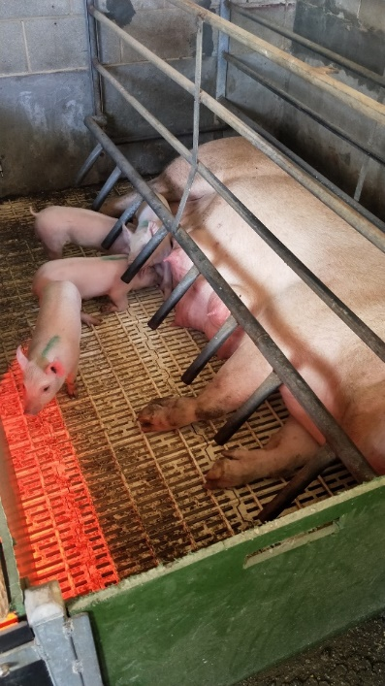
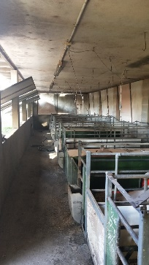
Figure 5: Farrowing Crates

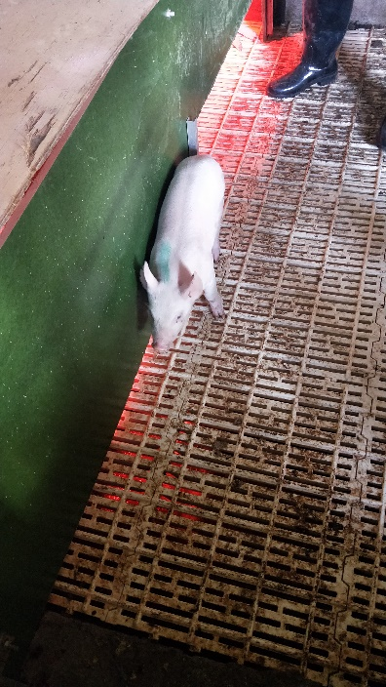
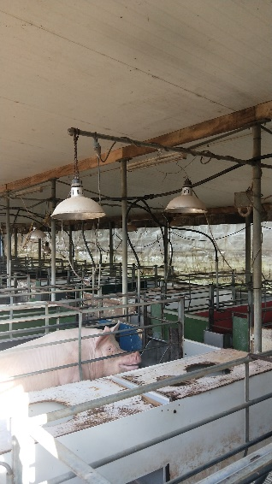
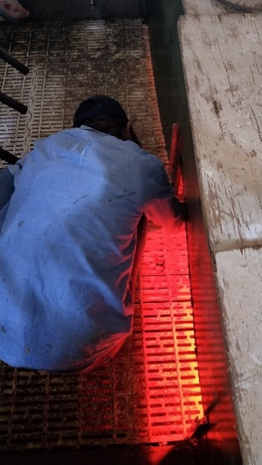
Figure 6: The ‘creep’

Figure 7: Plastic Flooring
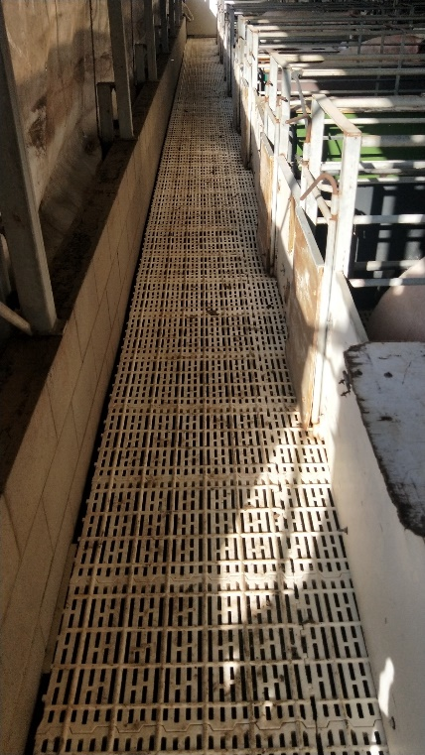
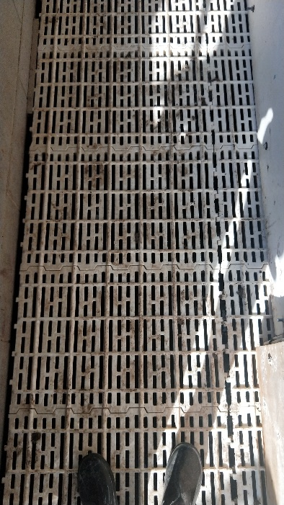

Figure 11 shows that there are three separate farrowing sheds-two close by and another further away. The largest farrowing shed contains two rooms of two rows of 20 farrowing crates, whereas the others have singular rows-one holding 8 crates and the other 11.
Once weaned, the pigs are moved on to the ‘weaner shed’. Shown in Figure 11, this housing component consists of numerous separate pens boarded by wood and plastic, that sit on the same grating as found in the farrowing sheds. Each pen holds 15-17 weaners, and pigs are grouped according to gender and size. For the first seven days, these pigs are provided with a heat lamp, and shutters (Figure 8) are continuously adjusted as needed. To reduce health risks and improve hygiene, every pen is cleaned and disinfected between changing groups. After spending approximately four weeks in this section of the farm, weaners are moved to ‘grower’ sheds.
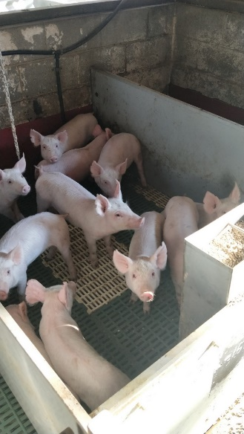
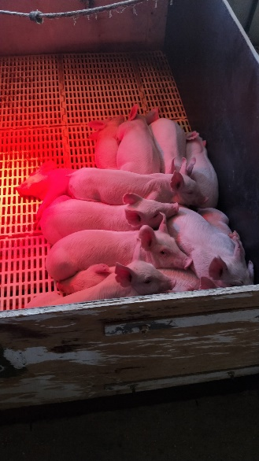
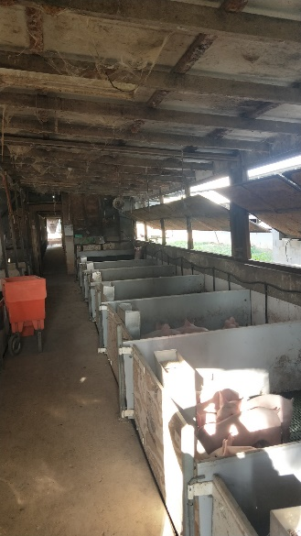
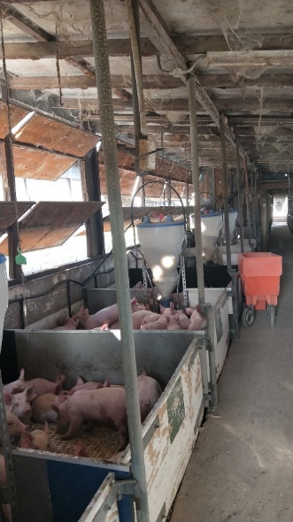
Figure 8: Weaner Shed
Around weeks 8-10 of the pig’s life, they spend their time in a grower shed (See Figure 9). All these transitions are dependent on the growth and development of each pig. Here they are grouped in concrete pens of 12, but as they grow each week, they are moved to bigger pens. Unlike the sows and weaners, growers are situated on concrete floors-meaning staff have to be more vigilant with cleaning. Shown in Figure 11, there are two grower sheds. The placement of pigs amongst these two sheds depends on growth rate, time and stocking rate. From week 10 onwards, pigs are classified as being in the ‘finisher’ stage. At this point, stock will most likely move to what is known as the ‘Top Shed’ facility.
Figure 9: Grower Shed
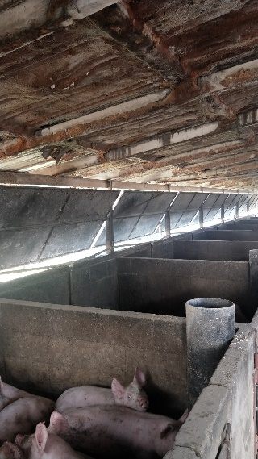
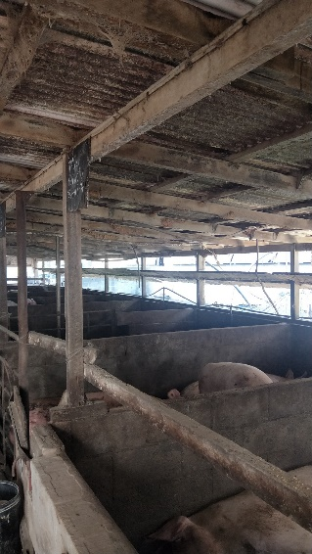
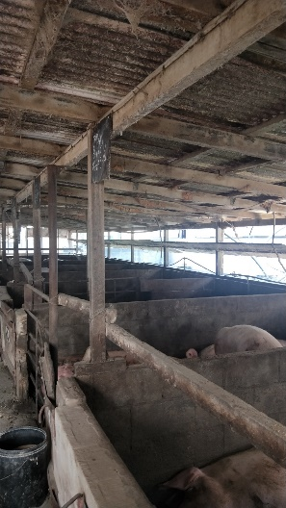
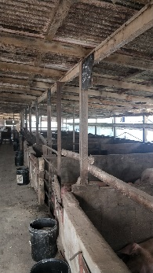

In the top shed facility, animals are grouped depending on what stage of growth they are at. Once at the top shed, it is only a matter of time until they are sold for profit. Most animals are sold anywhere from 10 weeks onwards. This is dependent on their growth rates, with an ideal finishing live weight of 85 kilograms.
However, all this explained above is the housing of those animals that are chosen for slaughter. This process is different for animals that have been selected as breeding stock. As suckers, it is noted which gilts may be kept to use as breeders based on teat formation, number and general conformation. Once at the top shed, these particular beasts are re-assessed at 23 weeks of age. If adequate for breeding purposes, these groups of 10-12 are moved back to the bottom shed facility-ready to be mated. Here, they stay in group housing until day 112 of gestation. After this, the animal is moved to a farrowing shed, (that has been previously discussed) resulting in the cycle starting again. Below is a table describing the basics of the HSS.
Figure 10: Basic Representation of Housing (by age)
Group/Age: | Housed at:
Selected Gilts | - Bottom Shed Facility-Grouped housing.  - 112 days gestation-moved to Farrowing sheds
Selected Boars: | - Bottom Shed Facility-Grouped Housing  - 28 weeks of age, moved to crates in mating shed
Dry Sows: | - Top Shed Facility: Housed in crates post service to 28 days pregnancy  - Once pregnant, moved into group housing  - Moved to farrow shed five days prior to birth
Lactating Sows: | - Top Shed Facility : Farrowing Sheds
Suckers: | - Top Shed Facility: In farrowing sheds with mothers
Weaners: | - Top Shed Facility : Group housed in weaner shed
Growers: | - Weeks 8-10, group housing in grower shed  - Weeks 10-finish: Top shed facility.
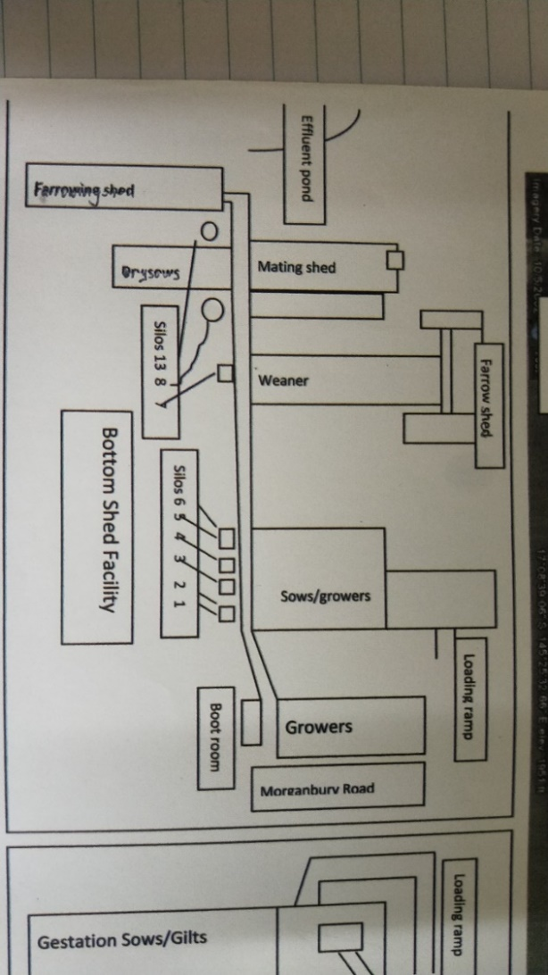
Figure 11: Bottom Shed Layout

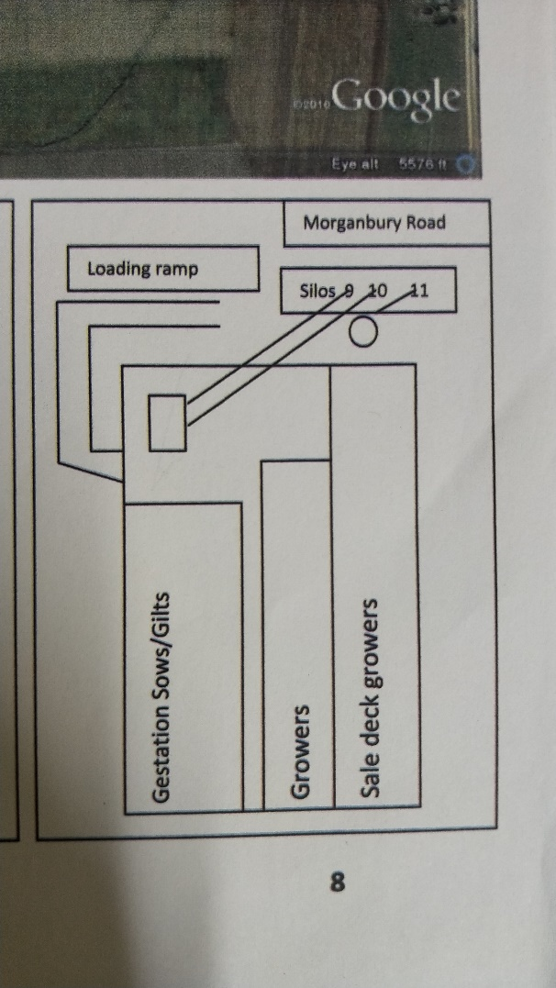

Figure 12: Top Shed Layout

Management Sub System (MSS):
As previously mentioned, Helen Bensilum is the piggery manager. Her role is to oversee the whole operation, by directing staff, controlling records and liaising with the owners. As manager, she is somewhat a chief decision maker. Helen has the power to make production and operational decisions, however she must talk with the owners, Chris and George about strategic decisions. She allocates her time within the piggery though successfully directing the other 2 staff members. The manager runs off one person per one hundred pigs, which is why there are two other employees. As discussed earlier, jobs are allocated effectively by giving each worker a different part of the farm to look after. Emma is a nursery hand, Terry is in charge of practical breeding and maintenance-leaving Helen to direct genetics and take records.
With the regard to the topic of records, the manager utilises a range of software technologies to track data. Data is collected and entered by Helen weekly into ‘Pigmania V7.00.141’, with entries made in ‘Sowtel’ quarterly. On top of this, excel is also sometimes used to manage records. The managing of data and records is crucial because it allows access to breeding history and tracking of diseases.
To keep up to date with industry news and technological advancements, Helen accesses a range of reliable sources. Technology updates are informed through the internet, research reports, newspapers, the local vet as well the Bi-Annual Pork Conference as well as the bi-annual Pan Pacific Pork Expo. On top of this, general information is sourced from Australian Pork Limited, Pork CRC, the Department of Agriculture and Fisheries (DAF), Australian Bureau of Statistics (ABS), universities and the Australian Bureau of Agricultural and Resource Economics (ABARES). Industry bodies that have influence on the enterprise include regulators as well as the Environmental Protection Authority (EPA).
With over ten years’ experience in intensive pig farming, the manager knows when problems are influential within the business. She reported that there are three current main inefficiencies within the system. The first is reproductive failures, the second is the growth rate in growers and the last is the nutrition of the pigs. This lead her to seek professional help regarding the nutrition of pigs, which would then hopefully have a positive effect on grower rates and fertility rates. This process is still being undertaken, so results are not yet accessible. As a motivated manager, Helen has three objectives in place;
- To improve reproductive efficiency
- Decrease the rat population (and therefore the risk of Erysipelas & Leptospirosis)
- Increase sow herd size from 268 to the maximum of 290
As with any business as manager, Helen still faces many challenges. As mentioned earlier in the introduction, the Australian industry as a whole is currently facing problems with market price. This has been felt even more in this enterprise as it is vertically integrated. Currently, pork is being sold for a $1.60/kg for baconers, which is ideally at $2.20/kg and porker price is $2.60/kg, rather than the ideal $3.20/kg. On top of this, the manager feels restricted in herd potential because there simply isn’t enough weaner accommodation. In order to get the herd back to its full potential, the weaner rooms must be expanded. In saying this, the problem is the make and age of the facility-something that is not easily changed.

Marketing Sub System (MSS):
The purpose of this sub-system is to effectively market the finished product in a way that returns the highest profit for the company. As discussed earlier, Greenwood Farming is a vertically integrated business, meaning all sections of production up to selling are controlled by themselves. This holds both positives and negatives. Positives include the benefits of vertical integration such as lower marketing costs, but negative experiences include the fact that they are bound by their own market. This is because they need a certain number of animals slaughtered each week, to satisfy customers. However, this is not always possible due to growth rates. Once the product is finished, the wholesaler (Morganbury Meats) buys the product, slaughters it and then markets it to local butchers and supermarkets. The owners of the enterprise chose this method of marketing because value is built in the vertically integrated model.

Outputs:
There are a range of outputs present within this enterprise. The one being of main interest for the farmer and manager is the pork product itself. This comes in different forms, porkers, baconers, cull sows and cull boars. The target for total kilograms of meat sold (in one year) is 334,466 kilos. However, 2016’s total fell 82,818 kilograms below this value. To further this, the target number of cull sows per year is 114, but 2016 exceeded this number at 129 sows. Also, the enterprise aims to output 110 porkers per week.
While these outputs are the money making ones, there are other outputs also. The first are dead pigs. These are dumped in waste pit at the back of the property, and later covered under 6 feet of dirt. The remaining output is the effluent. Once flushed from the pits, effluent sits in large ‘effluent ponds’. It is then taken and used as fertiliser for pasture which is then turned into hay. This is part of the vertical integration of the business, as when cattle are in need of hay the owners do not have to buy it.

Impacts on the system:
Natural Forces:
The natural forces that the piggery experiences includes everyday issues such as temperature and humidity, all the way to less prevalent ones such as cyclones. Humidity combined with high temperatures can have a range of negative impacts. These include a lower Feed Conversion Rate (FCR) as well as a decrease in fertility rates. As well as this, cold temperatures affect the pigs rarely. To try and manage this, shutters and curtains for ventilation and temperature control are in place.
Cyclones are less common, however when they impact, they have large impacts. This includes damage to property as well as stress for the pigs. The manager reported that pigs who experienced cyclones had increased stress levels, which therefore affected productivity. Nothing can be done to manage this natural disaster.

Cultural Forces:
Cultural forces such as animal liberation groups have influenced but not restricted the enterprise in the past. As a result of an animal liberation movement, new laws surrounding housing requirements were brought into legislation recently. This included the restriction of a shorter time allowed in farrowing crates, which therefore increased the group housing numbers. As a result of the facility being quite old, it was hard for Morganbury meats to adapt to this, because it was not set up for group housing. Changes were made to follow policy, but not without impact. This change resulted in a loss of 6% in production. As well as this, air quality lowered in group housing. In turn, this caused an increase in Ammonia levels, which resulted in a higher coughing rate in pigs.
Evolutionary Forces:
Evolutionary forces do not affect the piggery too much because it is an indoor system. However, the positioning of the system in relation to the creek has some affect. The creek in the property sits below the piggery, which is below the effluent pits. A major environmental concern is effluent going into the creek. Although it hasn’t happened, the manager and workers must constantly monitor the effluent ponds, ensuring they do not overflow. Another problem which contributes to this problem is the placement of the drain. Because the piggery is situated on a small hill, a drain runs through the centre of the property, towards the effluent pits. Not only can this drain cause some sections of the farm to flood, it also adds extra liquid to the effluent pits. This increases the risk of overflow.
Socio-economic Forces:
As discussed earlier in the Marketing Sub-System, the fact that the business is vertically integrated has some socio-economic impacts. Furthermore, the price as well as imports also explained in the Management Sub-System restricts the enterprise negatively.

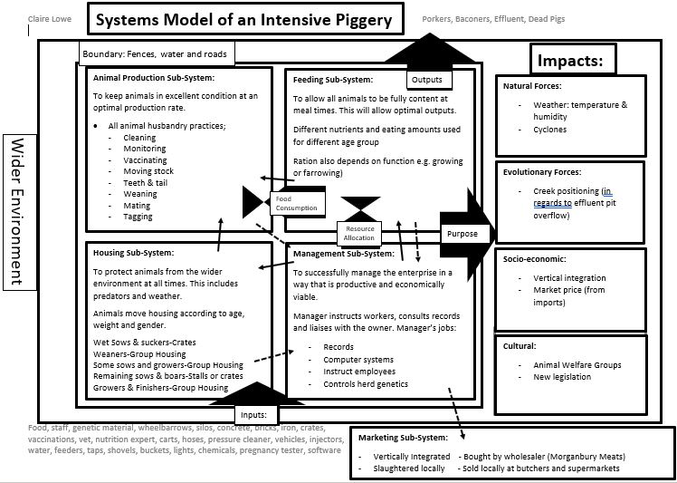
Systems Model:

Part B: Problem Solving Task
Although the management practices that are in place are effective, some problems were identified within the enterprise. After some discussion with the manager and consultation of past records, it was made clear that the farm is struggling with reproductive failures. This involves not only trying to get the animals pregnant, but also keep them pregnant. This issue was identified amongst weaned sows, other mated sows and gilts-showing that the problem is widespread across the enterprise. Mrs Bensilum believed that there were a few possible causes as to why this was happening. These include; the re-fit of the facility with incorporating group housing , a lack of sufficient quarantine, a lack of adequate nutrition and/or poor air quality. However, just recently the business employed a pig expert who is currently in the process of investigating and changing the nutrition of the pigs. Furthermore, at this stage nothing can be done about group housing due to legislation. Based on discussion and observation, I decided to choose the issue of air quality and humidity as it needed to be addressed. The fact that the other two contributing factors were in the process of being addressed or couldn’t be changed contributed to this decision also.
A poor air quality or some humidity may not seem as though it could have much effect. However, this is completely inaccurate. These two factors, especially when combined, can cause major havoc amongst not only the breeding stock, but all animals within the enterprise. For pigs especially, it is quite a big issue. This is because of one reason: science. Unlike other animals, pigs physically cannot sweat to get rid of excess body heat. The only sweat glands that pigs have are located in the snout, so apart from this, sweating is not a reliable way to lose heat (Rural Chemical Industries, n.d.). This means they must use alternative methods to maintain their body temperature. One of the first ways that a pig loses heat is through evaporative cooling in the lungs through panting. However, pigs’ lungs are relatively small, meaning that this method is not very efficient in high temperatures. To further this, pigs that have more subcutaneous fat are more likely to be affected by heat. This is because the fat blocks heat transfer, meaning more is trapped inside. So what does all this extra heat mean? Once temperatures rise above (as a general rule) 28ºc, and humidity reaches 30%, the health and condition of a pig will be affected (Agric.wa.gov.au, 2018). These figures are subject to change for breeding stock in particular, as they are more susceptible to being affected. The first way to recognise if a pig is stressed from heat is its breathing rate. As described by the Australian Pork 2013 Sow Infertility Manual, there are four different ranges used when describing the temperatures of pigs. The temperature range when pigs are most comfortable is called the Thermal Comfort Zone. Within this zone, pigs can control their temperatures by changing their position, splashing themselves with water and consuming more water. Below this is the Lower Critical Temperature (LCT), and above is the Evaporative Critical Temperature (ECT). However, when temperatures rise into ECT, they begin to pant at a beginning rate of 50 breaths per minute, all the way to 200 (King and Mitchell, 2013). Nevertheless, as temperatures increase, the pig pants faster and body temperature increases. At this stage, the animals are not only hot, but also stressed. Heat stress has also been known to affect fertility results, as well as have other side effects that in the end can affect this also. When stressed and hot, pigs will consume copious amounts of water, which increases the loss of electrolytes and causes a shift in the acid to base balance. This could in turn result in un-needed problems such as diarrhoea. If the temperature continues to rise into what is known as the Upper Critical Temperature (UCT), the pigs start to struggle with keeping their cool. At this point, the pig will experience a large increase in body temperature, resulting with the animal no longer being able to control or minimise the heat. Extremely high figures can lead to death, so if temperatures reach this point, human intervention is necessary.
Although the issues outlined above are not directly involved with fertility rates, they can contribute in worsening these figures. As a general rule, the healthier and happier the animal, the more likely they are to perform at what they do (in this case to do with pregnancy rates). In saying this, added heat, stress and humidity has been proven to have direct links to problems with sows and gilts. Increased heat is known to associate with pregnancy failure and late pregnancy loss (King and Mitchell, 2013). This corresponds with data taken from the enterprise of focus. This is backed up by research in France suggesting that higher temperatures results in a decrease of fertility rates (Peña et al., 2017). Within this report, it was stated specifically that impaired pregnancy function as well as increased foetal losses were prominent in unwanted higher temperatures.
The reproductive failures that the business is experiencing is not simply just another statistic, it is money loss-in many ways more than one. In order to ensure that breeding stock are in their best possible condition, thousands of dollars are injected in the forms of feed, water, vaccines, anti-biotics and care (human labour). If the sows are not reaching the optimal farrowing rate of 82%, this money is not being used effectively. As well as this, if the breeding herd is not producing ideal litter sizes or amounts, the enterprise income is again affected. One of the main purposes of an enterprise is to produce a product in a way that is economically viable. Once it was realised that the business was not operating as effectively as possible, research was undertaken and industry professionals were contacted.
After some extensive research online, it became clear that to address the issue at hand, physical changes would need to be made. As discussed earlier, pigs get to a point where they can no longer do anything themselves to maintain their temperature. With the area of Atherton often experiencing high temperatures and an even higher humidity, it became clear that the facility would have to undergo changes to ensure the optimal welfare of the pigs. After some initial research to understand the issue and possible solutions, industry professionals were also contacted to gain more insight as well as a reliable second opinion. The same paragraph (See Appendix) was sent to three different contacts, two of which replied, and one of which was furthered discussed with a more qualified individual. Tanya McKenna, the pig unit supervisor at the University of Queensland, responded with details on what their facility uses to control temperature and humidity (See Appendix). It was noted that they utilise “stir fans that operate on timers, water drippers & sprays that are set to come on at a set temperature and water misters on some fans”. She also recommended google searches, which were completed. The information she provided allowed for precise research to be undertaken, rather than a broader approach. The second contact was the research enquiries at Australian Pork. An employee named Donna provided me with links to information that I had not yet seen-all of which were extremely useful. She also passed it on to a pig specialist- Doctor Rebecca Athorn. Dr Athorn was extremely helpful, providing me with possibly the most valuable information of all contacts. As shown in (See Appendix) she suggested that “there could be many factors causing poor reproductive failures. If these failures occur at a certain time in the year (late Summer/ early Autumn) this can be caused by a phenomenon known as seasonal infertility (SI). Humidity can play a role in the occurrence of SI but temperature and day length will also contribute”. This suggestion of Seasonal infertility was one that had not been brought up in research, so it was decided to ask the enterprise manager if the rates were different at varying times of the year ((these discussions are still continuing)). As well as this, she recommended that “Ventilation systems or simply fans if placed correctly could help improve air quality. Regular flushing of effluent pits will also help”. This is to reduce the amounts of pathogens present in the air as a result from effluent vapour. To top it off, an extremely useful pdf was attached, one that was well utilised in the write up of this report. With all this professional knowledge on board, equipment needed to be understood and logistics planned.
As stated above, one of the recommendations by the professionals was to include water sprayers. The idea of this system is to saturate the pigs, which will allow the water to absorb the pigs’ heat, meaning it will then evaporate. As well as this, breathing rate can be reduced back to a normal 20 or 30 breaths per minute, thus reducing stress. One of the main benefits of utilising this system is the fact that (in comparison to other methods) it is relatively cheap and easy to install. One common way to install this system is as follows, from (Daf(1).qld.gov.au, 2018). A pipeline that can be suspended by a straining wire or the roof structure is usually positioned about 1800mm above the animal. This pipeline will have spray nozzles located above every pen, or in sections of the pen if in group housing. Positioning will depend on pen structure, location of feed and the type of animal being cooled. It is also important that the nozzles themselves point directly down to reduce drift. Generally, 350 millilitres of water over two to three minutes will take an hour to evaporate. However, this depends on the exact climate, with hotter climates possibly requiring sprays every half hour. In saying this, it must be made sure that animals are not sprayed in cold or windy conditions. This will only lead to body temperature going below the LCT, which will cause more harm than good for the pigs. To further this, water spraying is not suitable for lactating sows, as the risks for piglets becoming cold is too great. Thus this system is appropriate for dry sows/gilts or pregnant sows/gilts. For lactating animals, drippers rather than sprayers are recommended.
When installing drippers into a farrowing shed, it is crucial that the flow rate is adequate, as if it is too high the risk of water running into the creeps is very dangerous. This is because if piglets become wet or cold, they will lose condition rapidly and possibly die. The difference between sprayers and drippers is that the dripper system has singular drops, rather than spreading across the whole pen or animal. This system is set up the same way as sprayers, but this time positioned above the shoulder or rump area. It is important that where drippers are installed, there is drainage underneath. However, this is already satisfied with the current plastic grating previously discussed. It has been scientifically proven that drip cooling sows decreases embryo losses and produces fewer stillbirths.
Although it will make a significant impact, spraying alone will not solve the problem. Another way to control temperature is the housing structure and features. This includes insulation as well as controlling shutters. As a result of the facility being old, the original insulation on the sheds is mostly degraded. For this reason, it is recommended that new installation is installed to keep hot air out in summer and retain cool air in the hotter months. While there are a range of different insulation solutions on offer for commercial piggeries, spray polyurethane foam (SPF) insulation is recommended for this particular business. This is mainly because to use any other type of insulation, major renovations would have to be completed. Not only will this option be more economically viable, it will also have a range of benefits. SPF has been proven to reduce heat radiation, make buildings more water proof and maintain temperatures that are desired at different times of the year (Pragnell, 2016).
On top of this, a shutter re-fit is also recommended. The current sheds are naturally ventilated by large shutters that need to be manually re-positioned by staff. The two smaller farrowing sheds along with some dry sow sheds are equipped with these. The newer, larger farrowing shed on the other hand has roller blinds made of UV grade plastic. While this system of ventilation is much easier to control than the shutters, it is recommended that a whole new system is put in place. An automatic system that has a controller and thermometer in each shed will allow for changes to be made as necessary to the nearest degree. Not only will this allow a higher quality system, but it will also reduce the time labouring by manually moving and adjusting shutters.
Although implementing a new curtain system would improve ventilation and humidity increasingly, more would still need to be done. (CPR, 2005) states that for structures that are naturally ventilated, buildings should be separated by a distance of five times the height of the shed. However, this is not followed at this particular enterprise. For this reason, a fan ventilation system is suggested on top of the previous suggestions. Large industrial fans that are purpose built for piggeries are suggested. With research as well as extensive contact from a fan supplier-B & M Slots-it was decided that stirring fans were ideal for the current situation. This was because in order for most other systems to work, the buildings must be completely sealed. However, it isn’t economically viable to recommend this as large renovations would need to take place. As stated by the sales representative (See Appendix), stirring fans would be adequate for the task at hand. The point of these fans is to circulate the movement of air around the room, to keep it from becoming stale.
With so many varying recommendations, it was decided that to make the buying and setting up processes easier for the farmer, an all-round system should be purchased. This involves drippers, fans, shutters/rollers and ventilation equipment that is all controlled by one main control panel. Depending on the system chosen, this system should be capable of recognising and monitoring weather changes and patterns-including wind, humidity and temperature. This would allow for a stress-free system for the manager and workers. It can also be beneficial in times when staff are not as present (e.g. on the weekend).
However, before the details of this set-up are discussed, my planning ideas and motivations must be understood. As shown in (See Appendix) there are a range of sheds that house sows-mostly all of which are involved with breeding in some way. In saying this, not all sheds containing sows are going to be recommended for an update. The three farrowing sheds along with the large dry sow shed are going to be assessed. This is for a range of reasons. Firstly, some of the remaining sheds contain other groups of animals (growers) in addition to the sows. Also, one of the sheds has an open roof as well as lots of window ventilation, so an update is deemed not as crucial. Overall, it was decided not to asses all these remaining sheds for one main factor: economics. As this process is not going to very cheap, it is recommended that only these four sheds are updated. This will allow for a large-scale trial to occur, so results can be accumulated. The idea of this is to leave the possibility that the improvements do not have the desired effect, and therefore waste the owners money.
The first component as discussed is the spray/dripper system. Although a galvanised option could be selected, polyethene pipes were chosen due to ease of installation, prices and maintenance. According to (Daf(1).qld.gov.au, 2018), a 20mm polyethene pipe is sufficient for the purpose. Research was undertaken, and Netafim 19mm x 50m coils were sourced from Sunshower Online (Sunshoweronline.com.au, 2018). To have sprayers or drippers in all farrowing sheds as well as the large dry sow shed, roughly 150m of pipe will be necessary. At a price of $29.00 per 50m coil, the total price will come to $87. This is relatively cheap when compared to other prices on the market, as well as other options such as galvanised steel. To complete the set-up, spray nozzles are also required. Again, plastic was chosen over metal (brass) because of expenses. (Daf(1).qld.gov.au, 2018) recommended the use of irrigation micro jets. To make the ordering and invoicing process easier, spray nozels were also sourced from (Sunshoweronline.com.au, 2018). The Antelco Black Micro Spray Half Circle 1.7mm costs $0.21 per unit. The self-screw in system allows the farmer to put in the desired number of sprayers. As drippers will be used for farrowing sheds, roughly 45 micro sprayers are required for the Dry Sow Shed. This will bring the cost of sprayers to approximately $10. Furthermore, Antelco drippers are worth $0.54 apiece. With a maximum capacity of lactating sows of 59, this brings the price of sow drippers to around $32. Therefore, to install polyethylene pipe, sprayers for dry sows and drippers for wet sows, it will cost the enterprise a total of $129. This of course, is give or take due to changes in farmer wants or needs.
The next component of the whole recommended system is the stirring fans. A few different stirring fans were considered, however due to access of information and pricing, the Multifan TB-4E50 (See Appendix) was selected. Through consultation with a member from B & M Slots (B & M Slots Pty. Ltd., 2018) it was decided that ten fans would be needed for all four sheds. This decision was made going off the recommendation that fans are spread approximately twenty metres apart lengthways and ten metres apart width ways. It was also advised that where possible, one row should point one way and one row the other to avoid fans ‘fighting’ each other. This will also promote the circular motion of air. The price for a single unit is $590.18, bringing the price for ten fans to $5 901.80. The tables below represent the recommended layout for stirring fans.
Figure 13: Layout for Stirring Fans

8m
Large Farrow Shed

35m
3.5m
13m
Small Farrow Shed

4m
20m
Other Farrow Shed

8m
Dry Sow Shed
20m

With the advisements for evaporative cooling and ventilation in place, the shutter/curtain design must now be discussed. For this particular section, only the large farrowing shed and the dry sow shed are going to assessed. This is because the remaining two small farrowing sheds have only one open side that has shutters and doorways within this wall. This would make it tricky to design curtains that are worthwhile putting up. Also, at the time of industry experiences, sun was not noted as a problem for these particular animals (in comparison to others) Furthermore, the economics side was also considered. Two companies were rung by telephone for consultation of their products. Both Polytex (Polytex, 2018) and Darling Downs Tarpaulins (DDT) (Ddt.com.au, 2018) were contacted. In order to implement a curtain on both sides of the large farrow shed and dry sow shed, an approximate total of 110 metres was decided, at a height of 3 metres. Polytex quoted a price of $26/metre, with a total cost of $2860 (+GST), whereas DDT gave a price of $21/metre and a total amount of $2 301 (+GST). Solely for the purpose of economics, DDT’s product was chosen for an overall saving of approximately $550. However, in order to control this curtain, an automatic system is recommended. Rotem’s Curtain Winch as sourced from Munters via Mundingo has a unit price of $1 450 (+GST). As a result of high price, it is advices that automatic winches are only bought for the farrowing shed, and not the dry sow shed. This is because the automatic system will be more effective, therefore protecting the piglets and their heat-stressed mothers. The hand winches already present at the large farrowing sheds are advised to be taken off and used for the dry sow shed instead. This will help to reduce cost effects. For two automatic winches and enough curtain to cover the two sheds of focus, it will cost the enterprise approximately $5 201.
Now that all the components needed to control temperature and humidity have been explained and specified, the unit used to control them must be discussed. A whole range of automatic computer systems were initially researched, however it was narrowed down to two options. These are the Big Dutchman 307pro via Stockyard Industries (Ddt.com.au, 2018) and the Rotem SuperGuard via Mundingo (Rotem.com, 2018). Approximate quotes were given, with the 307pro quoted as $3 000 (+GST) and the SuperGaurd as $875 (+GST). Both systems had the power to control all the necessary components, as well as more. However, upon exploring brochures and information supplied by the employees of these companies, Rotem’s system, PigGaurd was chosen. This decision was mainly influenced by the fact that the SuperGaurd has a related system, the PigGaurd. Priced at $790, this computer has the ability to link to the SuperGaurd. This means that a smaller, cheaper PigGaurd can be placed in three of the sheds, with the remaining shed containing the ‘mother’ controller, the SuperGaurd. This would also result in a more economically viable solution when compared to the 307pro, as four of these units would have needed to be bought (due to four different sheds). Four Big Dutchman systems would have costed approximately $12 000. Compare this to the Rotem system, and it is significantly cheaper. Temperature sensors for this system are valued at $65 (+GST) and humidity sensors at $240 (+GST). With a temperature and humidity sensor needed for each shed, the total cost for all four Rotem units would be approximately $4 465. With this in mind, it is advised that the large farrowing shed contains the SuperGaurd, and the remaining three sheds have a PigGaurd. The sensors within these systems will relay back to the computers in each shed. Being an automated system, the computer will change curtains and fans as necessary and turn sprayer/drippers off or on as needed.
The combined total cost of sprayers/drippers, fans, curtains and computer systems will be approximately $15, 696.80. Although this may seem like a high figure, in the long run it really will be worth it. This system will allow the manager to focus more on other aspects of the enterprise, rather than devoting human labour to tasks such as adjusting curtains. Furthermore, the combination of these different components should theoretically reduce both temperature and humidity within the pigs, therefore increasing fertility rates. An increase in these rates will also benefit the enterprise economically, and soon enough will be able to pay back the amount it cost to buy these additions.
Although this entire system is highly recommended and put in place, some changes may need to be made on the enterprise. It was noted by the manager that a higher water pressure may be necessary to utilise sprayers, as the current lines are gravity fed. Before instillation, pressure within the farm may be considered. Furthermore, some of the components discussed may need access to 3 phase power, so this may be of interest also.
If the improvements prove successful for the business and fertility rates, I highly recommend that these components are added to all other sheds that sows are in. Furthermore, the idea of automatic shutters for the small and other farrowing sheds may be of interest.

Conclusion:
Overall, the owners, managers and workers combine effectively to run a successful business. In saying this, the recommendations as discussed are highly advised in the near future. These improvements would allow for better fertility rates, thus more piglets, then more pork which therefore results in the farmer benefiting off a higher income.
I am very fortunate to have had this opportunity to work at Morganbury Meats. The experience provided me with an insight into an enterprise that I knew next to nothing about. Not only did I learn how an intensive piggery operates, I also came to appreciate the time and effort put in to produce a quality product. This report in particular has inspired me even more to complete an Agriculture degree, as I enjoyed researching and recommending solutions.

Acknowledgements:
I would first like to thank the owners of the farm, George and Terry Greenwood, for letting me complete work experience on their property. I would also like to extend a huge thank you to the manager, Helen Bensilum, for not only showing me the operation of the piggery, but also welcoming me into her own home. Furthermore, I would like to thank her for her constant correspondence during the writing of this report. Also, I thank Terry and Emma for showing us around the piggery and how it all works. The last acknowledgements I have are for all the industry professionals who dedicated their own time to help me with this report. This includes: Donna (Australian Pork); Dr Rebecca Athorn (Australian Pork); Tanya McKenna (University of Queensland); Joe Oliveira (Stockyard Industries); Mike Anderson (Mundigo Pty Ltd); Evo Slots (B & M Slots); Trent (Polytex) and the rep from Darling Downs Tarpaulins.

Appendix:
Figure 14: Research Paragraph
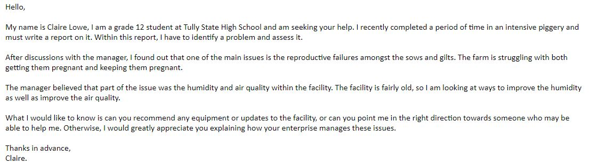
…

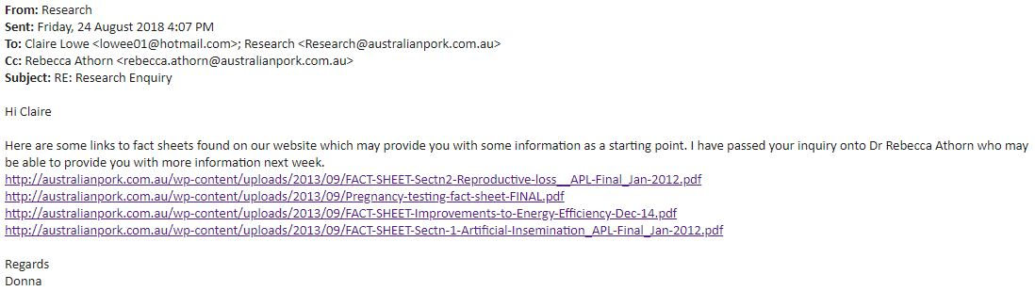
Figure 15: Response from Australian Pork
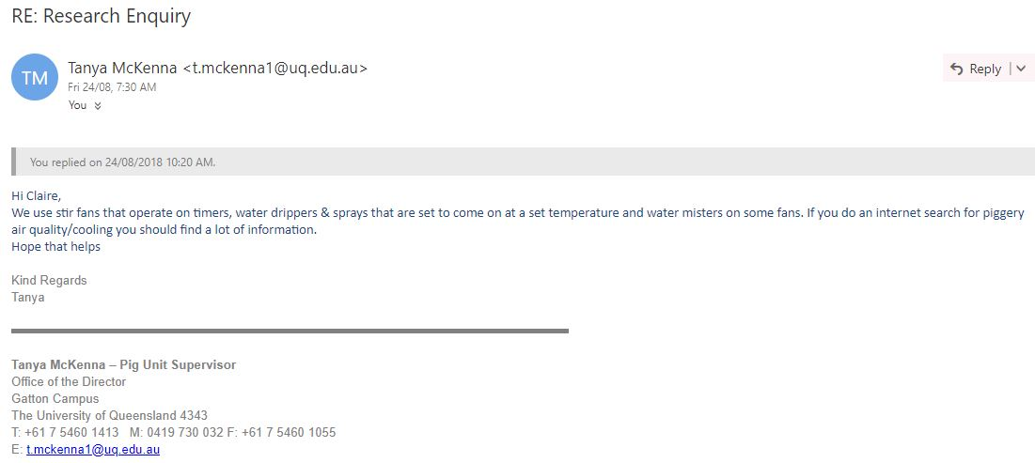
Figure 16: Response from UQ piggery manager

Figure 17: Response from Dr Athorn
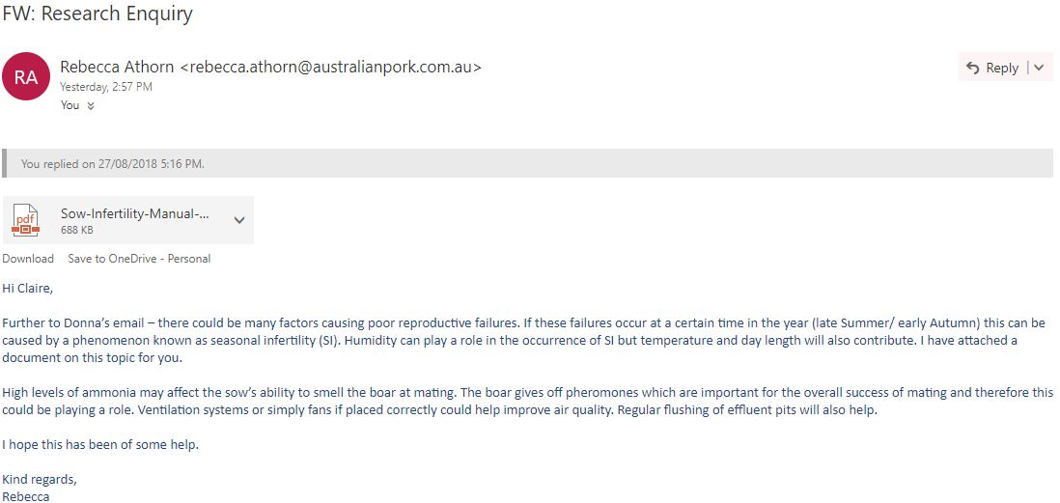

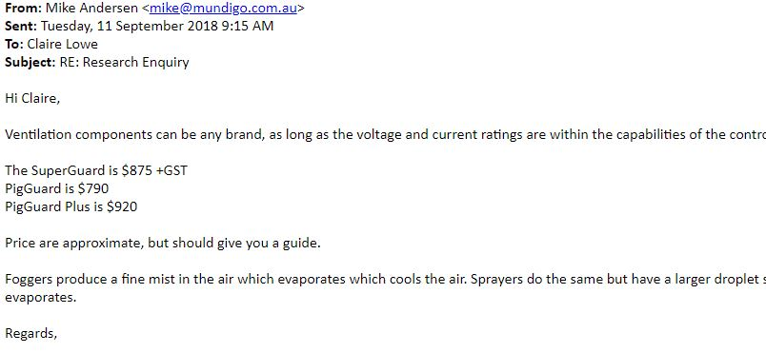
Figure 18: Contact with Mundigo Rep (Mike Anderson)
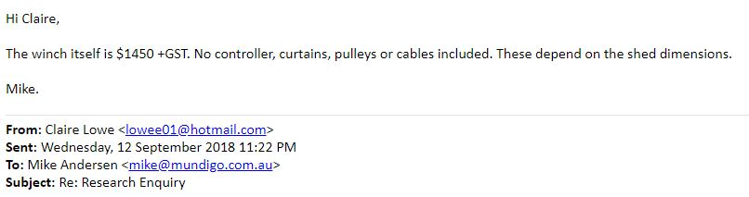
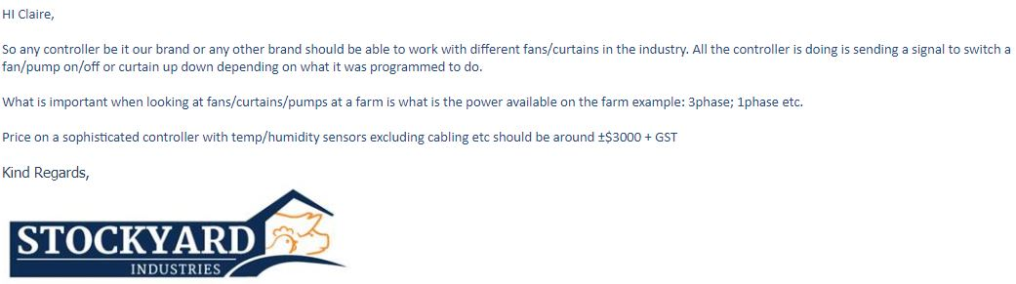
Figure 19: Contact with Stockyard Industries (Joe Oliveira)

Figure 20: Contact with Polytex (Trent)
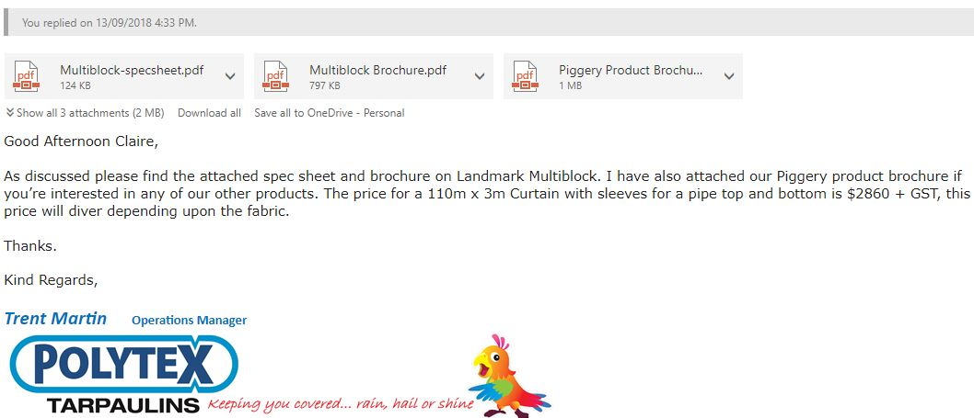

Figure 21: Multifan Figure 22: Curtain Winch
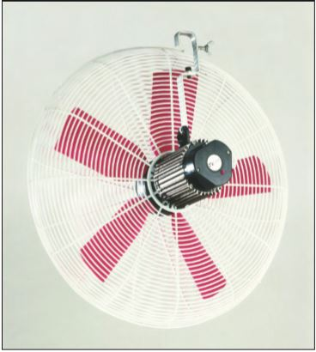

Figure 23: 307pro Figure 24: Rotem Supergaurd

References:
- BREED OF PIGS-LARGE WHITE
In-text: (NSW DPI, 2005)
Your Bibliography: Breed of Pigs-Large White. (2005). [ebook] NSW DPI. Available at: https://www.dpi.nsw.gov.au/__data/assets/pdf_file/0008/45566/Breeds_of_pigs_-_Large_White_-_Primefact_62-final.pdf
- BREEDS OF PIGS-LANDRACE
In-text: (NSW DPI, 2005)
Your Bibliography: Breeds of Pigs-Landrace. (2005). [ebook] NSW DPI. Available at: https://www.dpi.nsw.gov.au/__data/assets/pdf_file/0008/45557/Breeds_of_pigs-Landrace_-_Primefact_63-final.pdf
- AUSTRALIAN PORK LIMITED ANNUAL REPORT: 2016-2017
In-text: (APL, 2017)
Your Bibliography: Australian Pork Limited Annual Report: 2016-2017. (2017). [ebook] Available at: http://australianpork.com.au/wp-content/uploads/2017/10/Annual-Report-2016-2017_Final-web.pdf
- PLUNGE IN PORK PRICE ROCKS AUSTRALIAN PRODUCERS
In-text: (Financial Review, 2018)
Your Bibliography: Financial Review. (2018). Plunge in Pork Price Rocks Australian producers. [online] Available at: https://www.afr.com/business/farmers-under-pressure-as-pork-prices-crash-20180113-h0i08f
- COMPLIANCE PERFORMANCE REPORT-PIGGERIES
In-text: (CPR, 2005)
Your Bibliography: Compliance Performance Report-Piggeries. (2005). [ebook] Sydney: Department of Environment and Conservation (NSW). Available at: https://www.environment.nsw.gov.au/resources/licensing/piggery05123.pdf
- HOW TO SPOT HEAT STRESSED PIGS
In-text: (Rural Chemical Industries, n.d.)
Your Bibliography: Rural Chemical Industries. (n.d.). How to Spot Heat Stressed Pigs. [online] Available at: https://www.heatstress.info/HeatStressExplained/Identifyingpigssufferingfromheatstress.aspx
- HEAT STRESS IN PIGS | AGRICULTURE AND FOOD
In-text: (Agric.wa.gov.au, 2018)
Your Bibliography: Agric.wa.gov.au. (2018). Heat Stress in Pigs | Agriculture and Food. [online] Available at: https://www.agric.wa.gov.au/feeding-nutrition/heat-stress-pigs
- KING, D. R. AND MITCHELL, D. P.
Preparing for the Summer Months-Infertility and Beyond
In-text: (King and Mitchell, 2013)
Your Bibliography: King, D. and Mitchell, D. (2013). Preparing for the Summer Months-Infertility and Beyond. [ebook] Australian Pork. Available at: http://file:///C:/Users/Claire/Downloads/Sow-Infertility-Manual-November-2013.pdf
- PEÑA, S., GUMMOW, B., PARKER, A. AND PARIS, D.
Revisiting Summer Infertility in Pigs
In-text: (Peña et al., 2017)
Your Bibliography: Peña, S., Gummow, B., Parker, A. and Paris, D. (2017). Revisiting Summer Infertility in Pigs. [ebook] Available at: https://researchonline.jcu.edu.au/48348/1/48348%20Pena%20et%20al%202017.pdf
- SPRAY COOLING PIGS
In-text: (Daf(1).qld.gov.au, 2018)
Your Bibliography: Daf.qld.gov.au. (2018). Spray cooling pigs. [online] Available at: https://www.daf.qld.gov.au/business-priorities/animal-industries/pigs/managing-a-piggery/housing-pigs/spray-cooling
- ELECTIVE HUSBANDRY PROCEDURES | AUSSIE PIG FARMERS
In-text: (Australian Pork, 2018)
Your Bibliography: Australian Pork. (2018). Elective husbandry procedures | Aussie Pig Farmers. [online] Available at: https://aussiepigfarmers.com.au/pigs/our-animals/elective-husbandry-procedures/
- QUEENSLAND PIG INDUSTRY
In-text: (Daf.qld.gov.au, 2018)
Your Bibliography: Daf.qld.gov.au. (2018). Queensland pig industry. [online] Available at: https://www.daf.qld.gov.au/business-priorities/animal-industries/pigs/about-the-industry/in-queensland

- PRAGNELL, T.
Increasing chicken and pig farming yields with spray foam insulation
In-text: (Pragnell, 2016)
Your Bibliography: Pragnell, T. (2016). Increasing chicken and pig farming yields with spray foam insulation. [online] Sprayfoamsolutions.co.za. Available at: http://www.sprayfoamsolutions.co.za/News/entryid/4208/increasing-chicken-and-pig-farming-yields-with-spray-foam-insulation
- NETAFIM LOW DENSITY POLY PIPE 13MM X 50M COIL
In-text: (Sunshoweronline.com.au, 2018)
Your Bibliography: Sunshoweronline.com.au. (2018). Netafim Low Density Poly Pipe 13mm x 50m Coil. [online] Available at: https://sunshoweronline.com.au/pipe-fittings/poly-pipe-fittings/low-density-poly-fittings/netafim-low-density-poly-pipe?gclid=CjwKCAjwlejcBRAdEiwAAbj6KcYm95fCYqAtJM1nz3qoUGTd94f6jvKAaHYRTmI5NWxu6EiWwuke
- ANON
In-text: (Rotem.com, 2018)
Your Bibliography: Rotem.com. (2018). [online] Available at: http://www.rotem.com/pig-farming/superguard_and_piguard
- VENTILATION - B & M SLOTS PTY. LTD.
In-text: (B & M Slots Pty. Ltd., 2018)
Your Bibliography: B & M Slots Pty. Ltd. (2018). Ventilation - B & M Slots Pty. Ltd.. [online] Available at: http://bmslots.com.au/pork-production/ventilation/
- POLYTEX
In-text: (Polytex, 2018)
Your Bibliography: Polytex. (2018). Polytex. [online] Available at: https://polytex.net.au/
- DDT | AUSTRALIAN MANUFACTURERS OF QUALITY CANVAS, PVC AND POLY PRODUCTS INCLUDING TARPAULINS & SHADE PRODUCTS
In-text: (Ddt.com.au, 2018)
Your Bibliography: Ddt.com.au. (2018). DDT | Australian manufacturers of quality canvas, PVC and poly products including tarpaulins & shade products. [online] Available at: http://ddt.com.au/
- DDT | AUSTRALIAN MANUFACTURERS OF QUALITY CANVAS, PVC AND POLY PRODUCTS INCLUDING TARPAULINS & SHADE PRODUCTS
In-text: (Ddt.com.au, 2018)
Your Bibliography: Ddt.com.au. (2018). DDT | Australian manufacturers of quality canvas, PVC and poly products including tarpaulins & shade products. [online] Available at: http://ddt.com.au/

Power Point:

